An-Najah National University
Data Mining and Machine Learning
Heart Disease Prediction using Machine Learning

Students
- Ghada Qanazea
- Hamsa Ghanem
1. Introduction
Heart disease is a major health concern, and machine learning can help identify patterns associated with its occurrence. In this project, a Heart Disease dataset from Kaggle is used to predict whether an individual has heart disease based on medical and lifestyle features.
The project includes data preprocessing, PCA for dimensionality reduction, model development, cross-validation, and performance evaluation. Three classification models—Logistic Regression, Decision Tree, and SVM—are developed and compared to determine the most effective model for heart disease prediction.

2. Dataset Understanding
The dataset used in this project is a Heart Disease dataset containing medical and lifestyle information that can be used to predict the presence of heart disease. The dataset contains 10,000 samples and 21 columns, including 20 input features and one target variable, Heart Disease Status.
The input features include demographic, medical, and lifestyle attributes such as Age, Gender, Blood Pressure, Cholesterol Level, Exercise Habits, Smoking, Family Heart Disease, Diabetes, BMI, High Blood Pressure, Low HDL Cholesterol, High LDL Cholesterol, Alcohol Consumption, Stress Level, Sleep Hours, Sugar Consumption, Triglyceride Level, Fasting Blood Sugar, CRP Level, and Homocysteine Level.
The features consist of both numerical and categorical variables. Numerical variables include Age, Blood Pressure, Cholesterol Level, BMI, Sleep Hours, Triglyceride Level, Fasting Blood Sugar, CRP Level, and Homocysteine Level. The remaining input variables are categorical.
2.1 Target Variable
The target variable is Heart Disease Status, which represents whether a patient has heart disease:
- No: 8,000 samples (80%)
- Yes: 2,000 samples (20%)
Therefore, this project is a binary classification problem. The class distribution also shows that the dataset is imbalanced, since the majority class represents 80% of the samples.
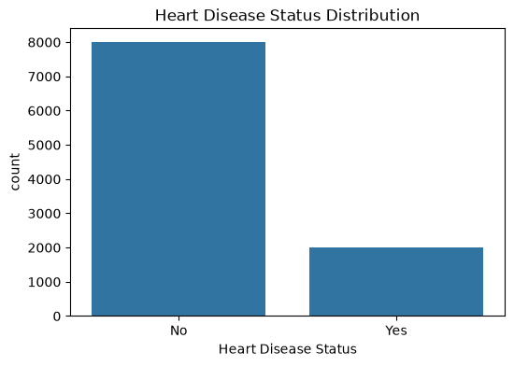

2.2 Missing Values
Missing values were identified in several features. Most variables contain only a small number of missing values. However, Alcohol Consumption contains 2,586 missing values (25.86%), which is considerably higher than the other features. The target variable Heart Disease Status contains no missing values.
The missing values will be handled during the preprocessing stage before training the machine learning models.


2.3 Feature Description


3. Data Preprocessing
Before training the machine learning models, several preprocessing steps were applied to prepare the dataset and ensure that the features were suitable for machine learning algorithms.
3.1 Duplicate Records
The dataset was checked for duplicate records. The analysis showed that there were 0 duplicate rows, so no records were removed.
3.2 Target Encoding
The target variable Heart Disease Status was originally categorical. It was converted into numerical form as follows:
- No → 0
- Yes → 1
This encoding was required because machine learning models operate on numerical target values.
3.3 Train-Test Split
The dataset was divided into training and testing sets using an 80/20 split:
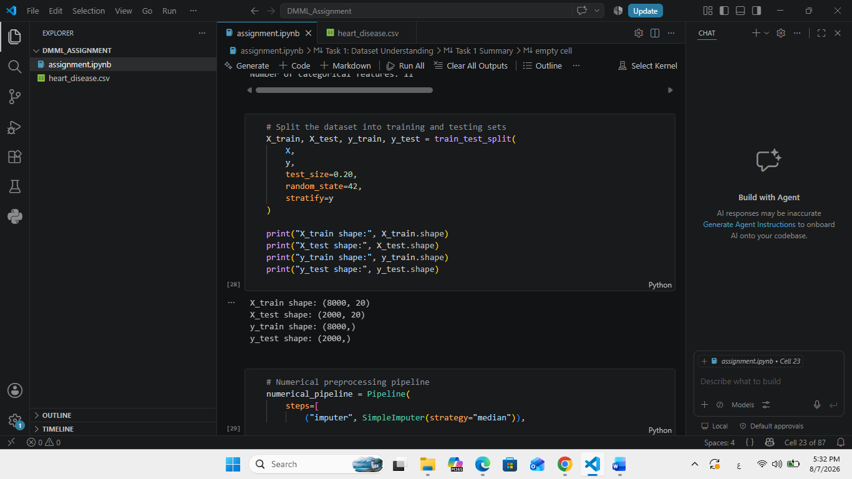
A stratified split was used to maintain the original class distribution in both training and testing sets.
3.4 Missing Value Handling
The dataset contained 3,054 missing values before preprocessing. Different strategies were used according to the feature type:
- Numerical features: Missing values were replaced using the median.
- Categorical features: Missing values were replaced using the most frequent value (mode).
The median was selected for numerical variables because it is less sensitive to extreme values, while the most frequent category provides a suitable replacement for categorical variables.
After preprocessing, both the training and testing datasets contained 0 missing values.
3.5 Categorical Feature Encoding
The dataset contained 11 categorical features. These features were transformed using One-Hot Encoding, which converts categorical values into numerical binary columns so they can be processed by machine learning algorithms.
As a result of One-Hot Encoding, the total number of features increased from 20 original features to 35 processed features.
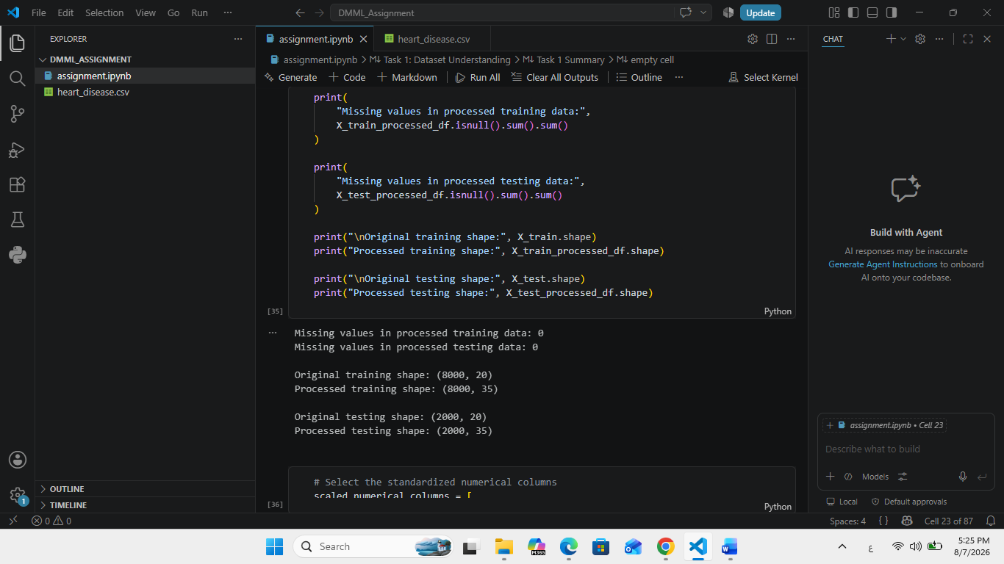
3.6 Feature Scaling
The 9 numerical features were standardized using StandardScaler. Standardization transforms the numerical variables so that they have approximately:
Mean = 0 and Standard Deviation = 1
The obtained results confirmed that the numerical features had means close to 0 and standard deviations of approximately 1 after scaling.
Feature scaling is important because the numerical variables have different measurement ranges, and it also prepares the data for PCA and scale-sensitive machine learning algorithms.
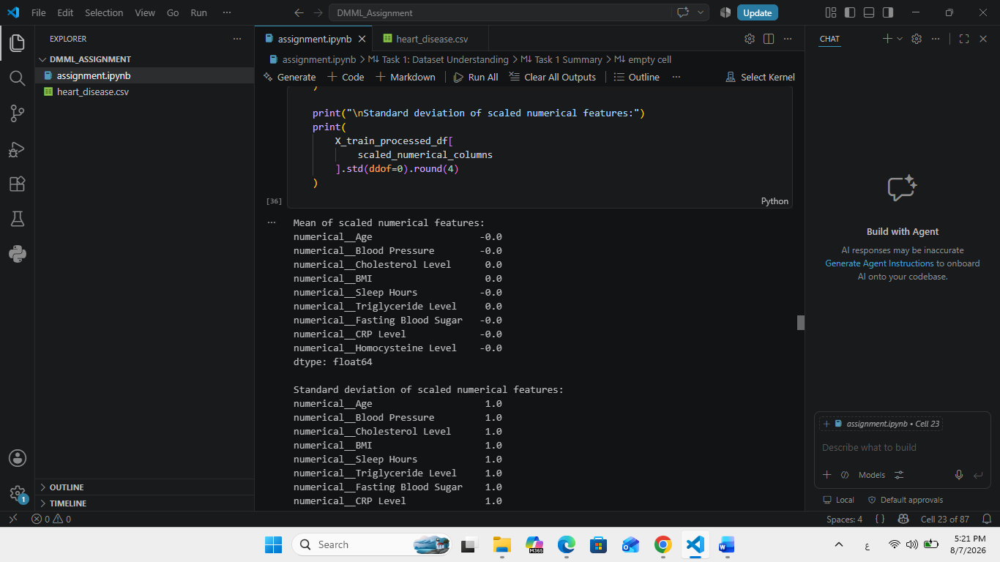
4. Principal Component Analysis (PCA)
Principal Component Analysis (PCA) was applied after data preprocessing and feature scaling to reduce the dimensionality of the dataset while preserving most of its variance. The processed dataset contained 35 features before applying PCA.
4.1 Explained Variance and PCA Transformation
PCA was initially applied using all available components to calculate the explained variance ratio and cumulative explained variance. The cumulative variance was then used to determine the minimum number of principal components required to preserve approximately 90% and 95% of the total variance.
The obtained results were:
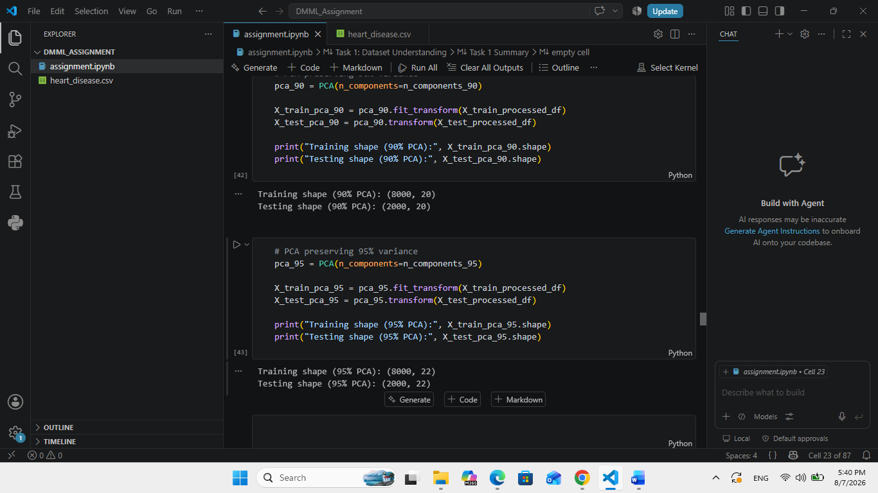
These transformed datasets will later be used to train and compare the machine learning models with the models trained using the original processed features.

4.2 Cumulative Explained Variance
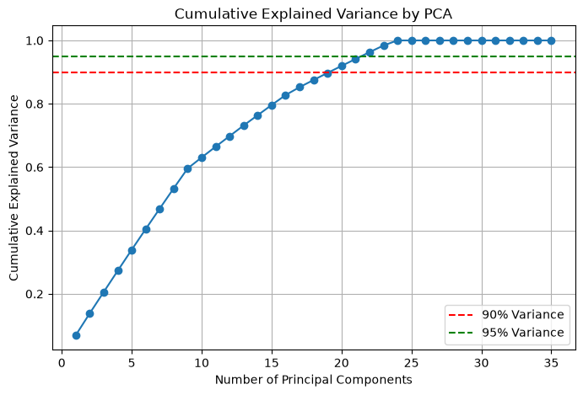
Figure: Cumulative Explained Variance by PCA
The figure shows how the cumulative explained variance increases as more principal components are included. The 90% variance threshold is reached at approximately 20 components, while the 95% threshold is reached at approximately 22 components.
4.3 Effect of Dimensionality Reduction
PCA reduced the number of features from 35 to 20 while preserving approximately 90% of the variance, or from 35 to 22 while preserving approximately 95% of the variance. This dimensionality reduction can reduce computational complexity, remove redundant information, and potentially improve model efficiency. However, reducing the number of dimensions may result in some information loss, especially when using the 90% variance representation.

5. Cross-Validation
To obtain a more reliable estimate of model performance, 5-fold cross-validation was applied to all nine model configurations. The training data was divided into five folds. In each iteration, four folds were used for training and the remaining fold was used for validation. This process was repeated five times so that each fold was used once as the validation set.
Accuracy was initially used as the cross-validation metric to provide a consistent comparison between the different model configurations. For each model, the mean accuracy and standard deviation across the five folds were calculated. The mean represents the average predictive performance, while the standard deviation indicates the variation in performance across the folds.

5.1 Cross-Validation Results

Model | Mean Accuracy | Standard Deviation
Logistic Regression - Original | 0.516 | 0.013
Logistic Regression - PCA 90% | 0.519 | 0.012
Logistic Regression - PCA 95% | 0.517 | 0.012
Decision Tree - Original | 0.772 | 0.011
Decision Tree - PCA 90% | 0.772 | 0.012
Decision Tree - PCA 95% | 0.774 | 0.011
SVM - Original | 0.484 | 0.044
SVM - PCA 90% | 0.518 | 0.015
SVM - PCA 95% | 0.482 | 0.044

The cross-validation results show that the Decision Tree models achieved the highest mean accuracy. The Decision Tree using PCA 95% achieved the highest mean accuracy of approximately 77.4%, followed closely by the Decision Tree using the original features and PCA 90%.
The Logistic Regression and SVM configurations achieved lower mean accuracy values. The relatively small standard deviations of most models indicate reasonably stable performance across the five folds, while the higher standard deviations observed for the SVM using the original and PCA 95% features indicate greater variation between folds.
It is important to note that accuracy alone does not provide a complete assessment in this dataset because the target classes are imbalanced. Therefore, additional metrics such as Precision, Recall, F1-score, and the Confusion Matrix were considered in the next stage.

6. Performance Evaluation
To provide a comprehensive evaluation of the classification models, the models were evaluated on the independent test set using Accuracy, Precision, Recall, F1-score, and Confusion Matrix.
Accuracy measures the proportion of all correctly classified samples. Precision measures how many of the samples predicted as having heart disease were actually positive. Recall measures the ability of the model to identify patients who actually have heart disease. F1-score provides a balance between Precision and Recall.
Recall is particularly important in this project because failing to identify a patient with heart disease represents a false negative. Therefore, the models should not be evaluated using accuracy alone.

6.1 Performance Result
Model | Accuracy | Precision | Recall | F1-score
0 | Logistic Regression - Original | 0.500 | 0.192 | 0.465 | 0.271
1 | Logistic Regression - PCA 90% | 0.506 | 0.191 | 0.453 | 0.268
2 | Logistic Regression - PCA 95% | 0.497 | 0.188 | 0.455 | 0.266
3 | Decision Tree - Original | 0.780 | 0.256 | 0.052 | 0.087
4 | Decision Tree - PCA 90% | 0.780 | 0.158 | 0.022 | 0.039
5 | Decision Tree - PCA 95% | 0.780 | 0.158 | 0.022 | 0.039
6 | SVM - Original | 0.480 | 0.193 | 0.505 | 0.280
7 | SVM - PCA 90% | 0.502 | 0.192 | 0.465 | 0.272
8 | SVM - PCA 95% | 0.471 | 0.200 | 0.547 | 0.293

6.2 Confusion Matrix Analysis
Confusion matrices were generated for all nine model configurations to examine the numbers of true positives, true negatives, false positives, and false negatives.
The results show an important difference between accuracy and the ability to detect positive heart disease cases. Although the Decision Tree models achieved the highest accuracy, their Recall values were very low. This indicates that they correctly classified many negative cases but failed to identify a large proportion of the positive heart disease cases.
In contrast, the SVM models achieved higher Recall values. The SVM using PCA 95% achieved the highest Recall among the evaluated configurations, approximately 54.8%, as well as the highest F1-score of approximately 0.293.
Therefore, the confusion matrices and class-sensitive metrics provide additional information that cannot be obtained from accuracy alone.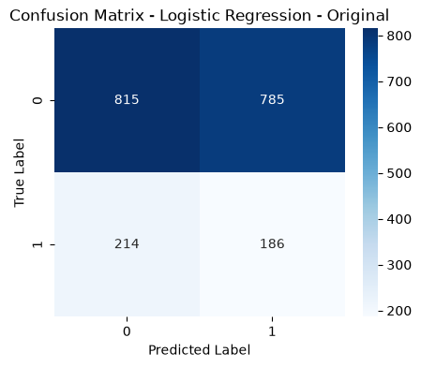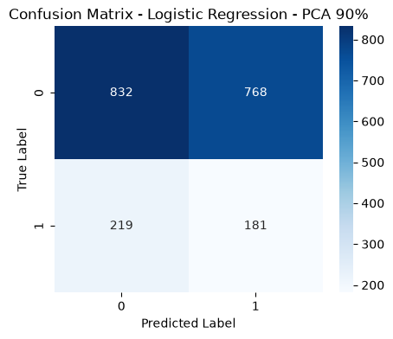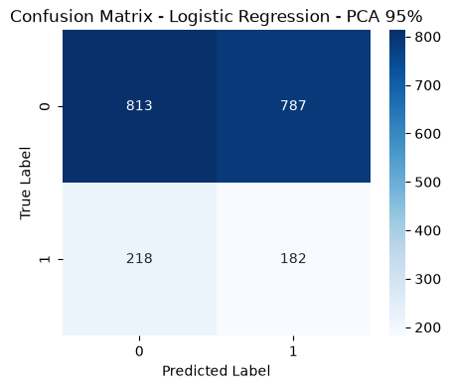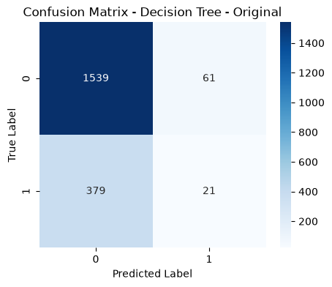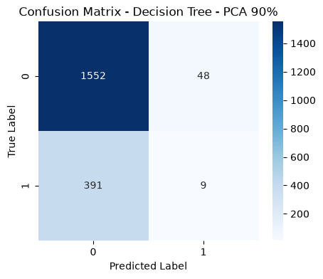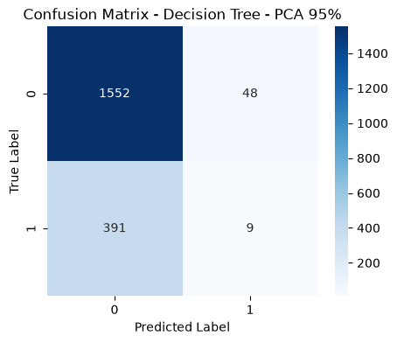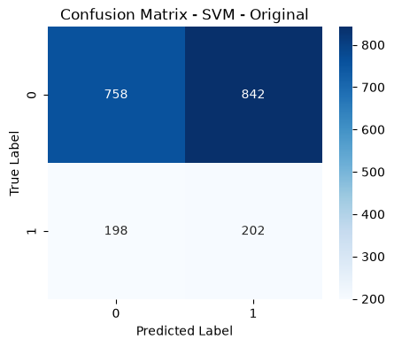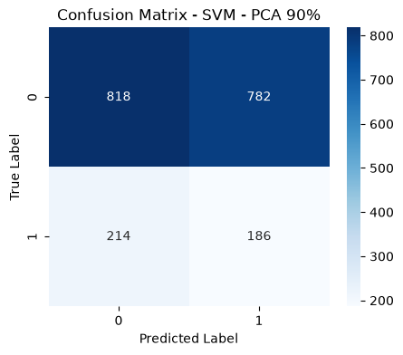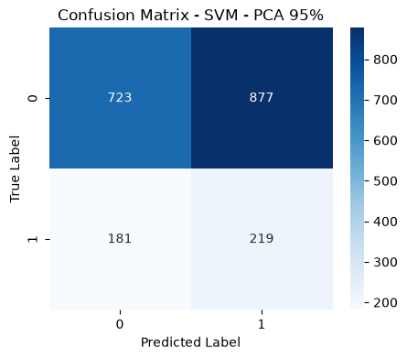

7. Comparative Analysis
The models were compared based on predictive performance, computational considerations, model complexity, and the effect of PCA.

7.1 Predictive Performance
Based on cross-validation accuracy, the Decision Tree configurations achieved the highest average accuracy, with the PCA 95% version reaching approximately 77.4%.
However, the test-set results show that the Decision Tree had very low Recall, particularly for the PCA-based versions. Since the main objective is to identify individuals with heart disease, this limitation is important.
The SVM using PCA 95% achieved the highest Recall (approximately 54.8%) and the highest F1-score (approximately 0.293) among the evaluated models. Therefore, it provided a better balance between identifying positive cases and maintaining reasonable precision.

7.2 Computational Cost and Model Complexity
Logistic Regression has relatively low model complexity and is generally computationally efficient. It also provides an interpretable linear relationship between the input features and the predicted class.
Decision Trees are relatively easy to interpret because their decisions can be represented as a sequence of rules. However, their performance can be strongly affected by the selected tree parameters.
SVM can be more computationally expensive than Logistic Regression and a small Decision Tree, particularly for larger datasets. However, PCA can reduce the number of input dimensions and potentially decrease the computational cost of SVM.

7.3 Effect of PCA
PCA did not improve every model.
For Logistic Regression, PCA 90% produced a slightly higher cross-validation accuracy than the original feature representation, while PCA 95% produced a similar result.
For Decision Tree, PCA 95% produced a small improvement in cross-validation accuracy compared with the original features. However, its test-set Recall decreased substantially.
For SVM, PCA 90% improved cross-validation accuracy compared with the original representation, while PCA 95% produced the highest Recall and F1-score on the test set.
These results demonstrate that PCA can affect different algorithms differently. Dimensionality reduction may remove redundant information, but it can also remove features that are useful for classification.

7.4 Model Selection
Based on the overall evaluation, SVM with PCA 95% was selected as the most appropriate model for this project.
Although the Decision Tree achieved substantially higher accuracy, its very low Recall indicates that it failed to identify many of the positive heart disease cases. In a medical classification problem, detecting positive cases is particularly important.
The SVM with PCA 95% achieved the highest Recall (approximately 54.8%) and the highest F1-score (approximately 0.293) among the tested configurations. It also reduced the dimensionality from 35 processed features to 22 principal components while preserving approximately 95% of the variance.
Therefore, SVM with PCA 95% provides the most appropriate balance between dimensionality reduction and the ability to detect positive heart disease cases.

8. Critical Questions

8.1 Did PCA improve every model? Explain.
No. PCA did not improve every model.
Its effect depended on the machine learning algorithm and the number of components retained. For example, PCA 95% slightly improved the Decision Tree's cross-validation accuracy, while PCA 90% improved the SVM's cross-validation accuracy compared with the original features. However, PCA also reduced some test-set metrics for certain models.
This occurs because PCA transforms the original features into new uncorrelated components. While this can remove redundancy and reduce dimensionality, it may also remove or combine information that is useful for classification. Therefore, PCA should not automatically be expected to improve every model.

8.2 Why is cross-validation more reliable than a single train/test split?
Cross-validation is more reliable because it evaluates the model using multiple training and validation partitions instead of relying on only one split.
In 5-fold cross-validation, the dataset is divided into five folds and the model is trained and evaluated five times. Each fold is used once for validation, while the remaining folds are used for training.
This provides a more stable estimate of model performance and reduces the possibility that the results are strongly affected by one particular train/test split. The mean and standard deviation also provide information about the model's average performance and stability.

8.3 Which evaluation metric best represents your chosen model and why?
For the selected SVM with PCA 95%, Recall is particularly important because the main concern in heart disease prediction is identifying patients who actually have the disease.
A false negative means that a patient with heart disease is incorrectly classified as not having heart disease. Therefore, a model with a higher Recall is better at detecting positive cases.
However, Recall should not be considered alone. The F1-score is also important because it considers both Precision and Recall. In this project, SVM with PCA 95% achieved the highest Recall and F1-score among the evaluated models, making these metrics particularly relevant to the model selection.

8.4 Under what circumstances would PCA not be beneficial?
PCA may not be beneficial when the original dataset already has a small number of meaningful features or when dimensionality reduction provides little computational advantage.
It may also be unsuitable when interpretability is important because PCA transforms the original features into principal components, making it more difficult to directly interpret the contribution of individual original features.
Furthermore, PCA may remove information that is useful for prediction, particularly when components with relatively low variance contain important information for the target variable. Therefore, PCA should be applied only when its effect on model performance and computational efficiency justifies the loss of interpretability.

References
https://www.kaggle.com/datasets/oktayrdeki/heart-disease

